To clear the browser cache:
- Open Edge and click the ellipse in the upper right corner of the browser.
- Then Settings
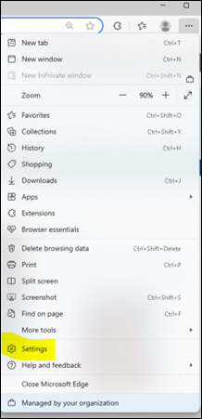
- Select Settings >

- Settings > Privacy, search, and services> Clear browsing data 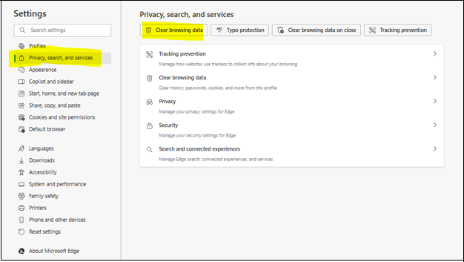

- Select Clear now
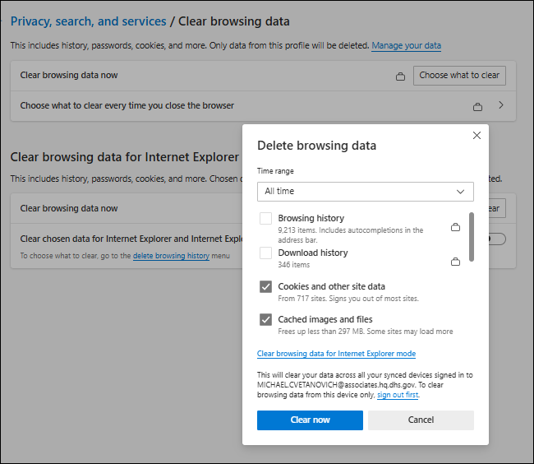

- These Cookies and site data switches should look like these below:
